**A REVIEW ON BIOMECHANICAL PROSTHETICS**

Hemanath, Second year Under Graduate, Mechatronics Engineering.

<hemanath.18mc@kct.ac.in>

Prakash, Second year Under Graduate, Electrical & Electronics Engineering.

<prakash.18ee@kct.ac.in>

Vishal, Second year Under Graduate, Mechatronics Engineering.

<vishal.18mc@kct.ac.in>

Department of Mechatronics Engineering, Kumaraguru College of Technology, Coimbatore.

Abstract: *Active prosthetic devices to replace missing arm or hand have much in common use with robotic manipulators for industrial tasks. However, the design of an upper limb prosthetics presents a set of mechanisms which may differ considerably from those in other robotics situations, while the needs of prosthetics users are highly individual. In addition to the robotic arm, Prosthetics plays a major role in the Human medicinal field. The degree of loss can vary from a partial hand up to a complete arm including the shoulder. Prosthetics can be used in both medicine and medical fields. Variants are needed to cater for different sizes and the two sides.  Control straps and cables fitted on the person are responsive to body movements of the person for selectively locking the elbow joint to prevent it from pivoting while allowing the terminal device to open or close or locking the terminal device to prevent it from opening or closing while allowing the elbow joint to pivot. This presentation is a simple mechanism that explains the working and the use of Prosthesis in addition to the robotic arm.*

**Keywords: Robotic dextrous manipulators, robotic application, standardized design, partial hand, shoulders, body movements, elbow joint**

--------------------------------------Section Breaks---------------------------------------

**1. INTRODUCTION**

Prosthetic arms did not appear in our history until the age of ancient Greek and Roman times. Although these types of prosthetics were not that much functional. In the United States, the demand for prosthetics has drastically increased after the Second World War. Due to this demand, U.S. army signed contracts with different companies to design a prosthetic for damaged amputees. This led to the creation of the American Orthotic and Prosthetic Association (AOPA), which creates prosthesis. Since then the production of prosthetics has increased massively. But it is unknown that they are used in medicinal purpose too. In the past century, these devices have improved extraordinarily. The composite materials were replaced with much lighter materials like aluminum or thick plastics, to provide comfort for the consumers or patients. Besides, robotics have played a major role in the revolution. These prosthetics arms and legs were designed to help amputees to enjoy the lifestyle that they were accustomed to. Further, these prosthetics were used for safety purposes and in military too. Overall my project aimed to improve prosthetic arms similarily way at a low cost. This information will help to design an ideal prosthetic arm for consumers from eighteen to fifty aged persons.

**1.1 Inventors of Prosthesis**

George C. Devol, a huge self-taught genius and inventor, who drew from science fiction to help the development of Ultimate, the revolutionary mechanical arm that became a great prototype for robots now widely used on automobile assembly lines and in other industries, he died on Thursday at his home in Wilton, Conn. In the early 1950s, before the advent of industrial robotics, Mr. Devol built his own work in electrical engineering and machine controls to design a mechanical arm that could be programmed to repeat specific tasks, like grasping and lifting. He applied for a patent in 1954. Further, his finding gives rise to a new prosthesis mechanism.

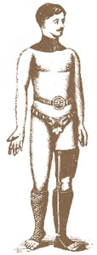

*Fig; 1 The beginning stage of a prosthesis*

Van Phillips is an American inventor, who invented prosthetics. He is known for his flex foot brand of artificial foot and limbs that he created.

From the ancient pyramids to World war, the prosthetic filed played a sophisticated example of man’s determination to do better.

The evolution of prosthetics is a long and storied history, from its primitive is a long and storied history, from its primitive beginnings in olden age to its sophisticated present to the exciting visions of the future. As in the development of any other field, some new ideas and inventions have worked and been expanded upon such as the fixed position foot while others have been fallen by wayside or become bionic such as the use of the iron in a prosthesis.

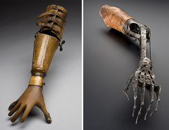

*Fig: 2 Prosthetics arm made of wooden and steel*

And their inventions gave rise to discover a new high-tech prosthesis with the use of Nanotechnology and other microcontrollers. In addition to the prosthetic arm, a highly well-performed prosthetic leg is also developed. With the use of sensors, we can control its specific flexibility.

**1.2 Evolution of prosthesis**

In 1696 Pieter Verduyn developed the first non-locking prosthesis which can be fixed below the knee. In 1800, James Potts, from London, designed a prosthesis made of a wooden shank and socket, a steel knee joint and an articulated foot that was controlled by catgut from knee to ankle. It would become known as “Anglesey Leg”, after Marques of Anglesey who lost his leg in the battle of Waterloo and wrote the leg.

In 1846 Benjamin Palmer saw no reason for leg amputees to have an unsightly gap between various components from materials and improved upon the Delphi legs. As the U.S. Civil war dragged a huge number of amputations rose astronomically forcing Americans to enter the field of Prosthetics.

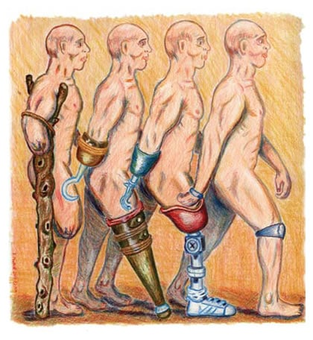

*Fig: 3 The improved of prosthesis*

James Hanger one of the first amputees of civil war developed the patent as “Hanger Limb”. People such as Hanger, Selpho, Palmer, and A.A. Marks helped to transformation and advancement of the prosthetics field.

From the beginning of the modern years, man uses prosthetics and prosthetic technology. Their rudimentary prosthetic limb was made of fiber and wood.

An artificial leg which was held under Radio carbon dating and found that 300 B.C., ago unearthed at Capua, Italy in 1858. It was found that it is made of Bronze and iron.

In between 476 A.D., and 1000 A.D., man uses wooden hands and legs. When their hands or legs were injured or destroyed. It was a common use of tradesmen such as pirates including armorers to design and create artificial limbs.

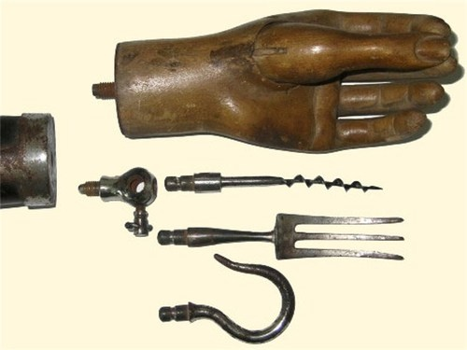

*Fig: 4 Arm which was used by pirates*

Another story printed in history about a silver arm was made for Admiral Barbarossa who fought the Spaniards in Bougie, Algeria for the Turkish Sultan. A French Army surgeon Ambroise Pare is convinced by many people in the country to hold the title for the father of modern amputation surgery and prosthetic design. He introduced modern amputation procedures in 1529 A.D. for the medical community.

**2. Methodology**

A real exact prosthetic requires a large amount of cost but by following my method it’s really easy to make a prosthesis. The components require an Micro-controller board, nRF24L01 transmitter, flex sensor, servo motors, steel coin spring, glove, F to F jumper, M to M jumper, Breadboard, Foamboard, Battery, 10k ohm resistors, nylon string, Hot glue and a cable ties.

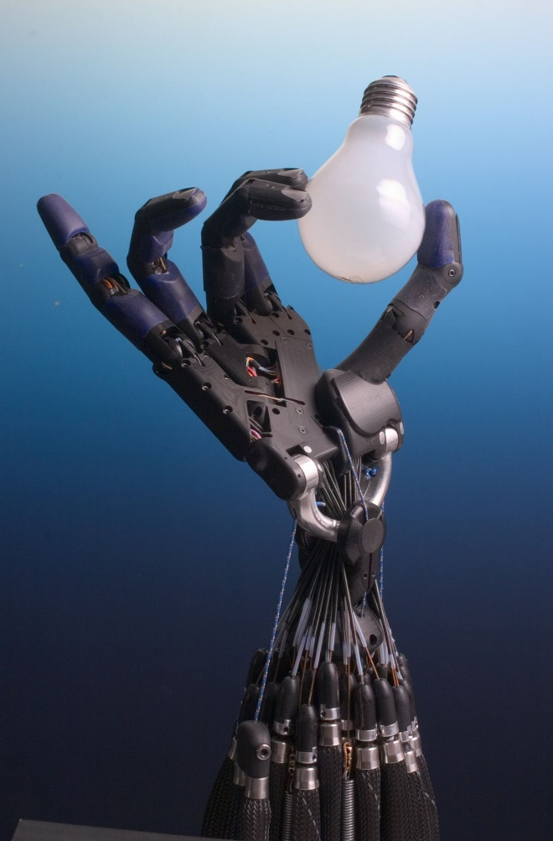

*Fig: 6 From this picture threads and nylon can be used for moving fingers.*

Make the fingers with use of foam board, cut it with a knife or some other sharp objects and just coat it with plastic. Insert the spring into the foam and connect the nylon into it. Fix the 5 servo motors on the wrist of the foam by making a hole inside the foam hand. Stick it with the hot glue. Place the Micro-controller board on the hand, make simple connections with breadboard, battery and finally connect it to the servo motors. Make sure that the hot glue is stuck properly to the foam, sometimes the glue doesn’t stick to the foam. Make connections to the Micro-controller board properly for an effective connection. For a perfect prosthetic arm the wiring connections to the Micro-controller and breadboard has to be made perfectly. Then finally insulate the jumpers, fix the nRF24L01 transmitter to the hand using the hot glue in addition to the Micro-controller. Fix the transmitter near to the breadboard, the nRF24L01 transmitter module also contains the receiver in addition to transmitter.

Now move on to the glove part. Fix the flux sensors to the fingers of glove in a suitable position. Properly insulate the tape. Directly fix the 9V battery to the Bread board with the use of Resistors.

Fix the nRf2401 module with the Micro-controller board as much as carefully. Connect the Micro-controller and jumpers by its connections. And when the connection with Micro-controller board is over, the robotic prosthesis is half done.

Just upload the programs into the Micro-controller board. When you carefully notice that both the Micro-controller has different coding on its basis. As we can clearly notice that this prosthesis doesn’t have any switch connections to switch it on or off. As when the battery is connected to the breadboard it gets powered and regulated. It’s clear that the prosthesis doesn’t require a large amount of power supply. It just requires two set of 9V battery.

**2.1 Working**

The mechanism of simple Micro-controller-controlled prosthesis works based on the conduction produced in the flux sensors. As the conductance of sensors increases, the servo motors rotate according to it.

The working of simple prosthetics involves the following methods. When the current is passed from the 9V battery it supplies current to the flux sensors. Due to the electrical conductance is produced. As we move up the fingers the conductance and pressure get varied, so that the Micro-controller converts the conductance into analog value, this value is then further transmitted by the nRF24L01 transmitter module. Then another nRF24L01 receiver on the other side which is fixed to the servo motor receives the analog values and convert those into analog outputs. These analog values are recorded by Micro-controller board and convert its outputs into potential to further transmit power supply to servo motors. And hence servo motors rotate up to 90° based on analog value produced by flux generators. Servo motors rotates according to analog values and it pulls the finger through the threaded nylon.

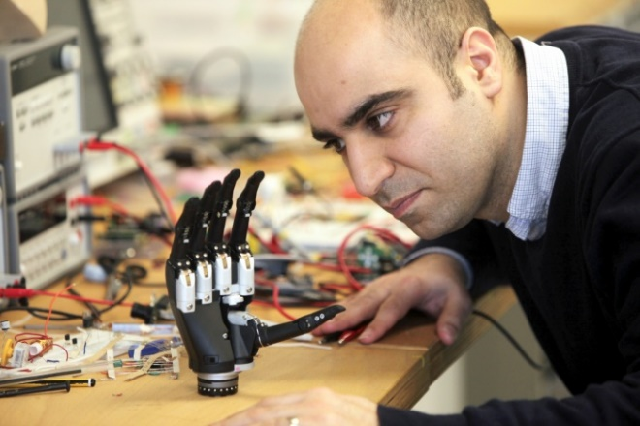

*Fig: 6 Modern prosthetic arm with highly qualified circuits.*

**3.** **Scientific advantages**

The science-fiction vision of robotic prosthesis limb that can be controlled by the brain and provide sensory feedback is coming closer. The world and it’s biological systems have and millions of years to evolve solutions for various problems posed by the environment, civilization, by contrast, had more centuries. Engineering some devices that will have to fulfill the same functions as a natural part of the body or co-ordinate with natural. The human uses motorized prosthetics in popularized with the name “Bionic”. A decade later, we saw the right hand of Star Wars Hero Luke Skywalker wrist is natural and extreme.

There are two main challenges involved in the development of prosthetics. The first is in designing the mechanical limb itself. With increasing miniaturization of electric motors and advances in computing power, this is becoming less of a challenge than the second still towering difficulty, finding ways to interface the machine with amputee’s body. It is even closer to get towards nature with prosthetics.

Myoelectric control depends very strongly on the fit between stump and prosthetic because the sensors that detect the muscle signal have to be precisely placed on the correct area of skin on the body.

The lightweight prosthetics invented by Dr. A. P. J. Abdul Kalam was just 400g. It keeps strategy on many physically challenged person to keep on moving forward in lifestyle.

Advanced lower extremely prosthetics are equipped with a variety of mechanisms that helped them to move naturally as a patient walk or runs prosthesis can be used for temporary patient’s loss of leg to physically challenged person.

If electrodes can sense the electricity caused by the muscle contractions why can’t they just go-to source of information and measure the electrical signals carried in nerves or even brain. For example, electrical signals in the brain and nerves are very small and hard to access. The field of neural interfacing is dedicated to developing ways to listen and communicate with brain and nerves.

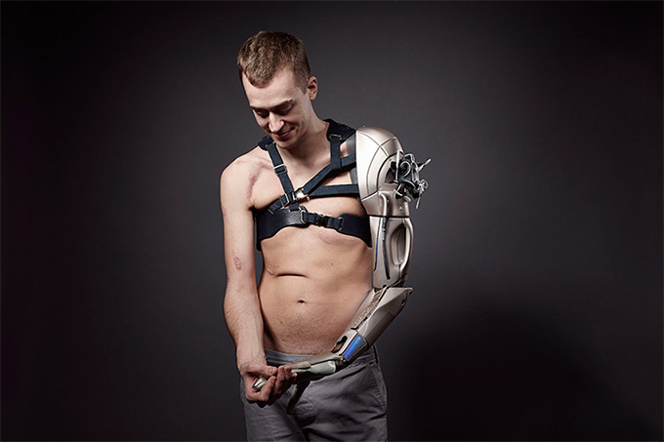

*Fig: 7 Alternatives for people who lost their arms.*

Further in neural interfacing with the body will allow some artificial devices to more effective stimulation of the nerves or brain to restore a sense of touch and allow patients to feel their artificial limb. This capability will go a long way in closing the gap between the prosthetic limb and natural limbs.

Further, these prosthetics get connected to the nerves of the human brain and acts according to the stimulation of the nerves given by the human body.

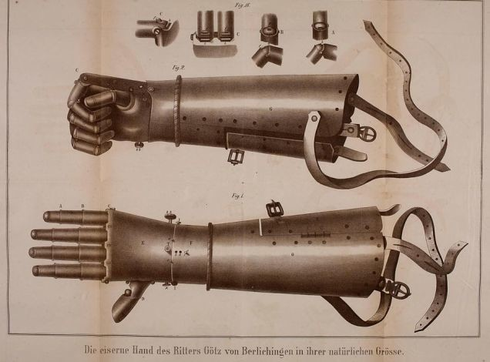

*Fig: 8 Fixable prosthetic arm.*

**3.1 Prosthesis in radioactive industry**

In radioactive industries, it is extremely harmful to work with radioactive elements by the humans, later revolutionary periods gave rise to the use of prosthetics. By monitoring via computer from a long distance and operating the prosthesis using a wireless module prevents harmful radioactive rays on human beings. Nowadays robotic arms are just used for working with certain non-hazardous elements. Uses of a prosthesis in these hazardous areas reduces harmfulness to human beings. This can be achieved by simple use of the sensors and Micro-controller boards and with further equipment.

Robots have been normally developed by human to reduce the harmful effects on human and to reduce the work. As the radioactive rays which are harmful to human beings can cause damage to the DNA. So, in place of human workers, it has been replaced by robotic arm and prosthesis.

In addition to the radioactive industry, it has been used in Nuclear power plant technology. As above 250mR radiation can cause side effects, it extremely dangerous to work in nuclear power plants. Hence the use of Prosthesis and other use of Robotic arm lets the people to work away for this radiation. In this similar way, radiation on human beings can be neglected. This robotic arm and prosthesis can be regulated and monitored from a long distance and hence it is safe.

Working of human beings in nuclear power plant can affect the DNA of that person. In the alternative of reducing these hazards, we use a prosthesis and a robotic arm.

**3.2 Benefits**

Patented technology allows operators with no programming experience to quickly set up and operate our prosthesis. The out of box experience for an untrained operator to unpack the robots, mount it and program for a first simple basic task is typically less than an hour.

This will reduce the effects produced by the gamma rays. In addition to nuclear power plants, they are also used in pressured and high stressed areas, were the human health doesn’t support that condition.



*Fig: 9 nuclear power plants which also uses prosthesis in addition to the machines.*

Universal Robots are lightweight, which are space-saving and easy to re-deploy the system multiple applications without changing your production layout.

The safety system of our robots is approved and certified by the TUV (The German Technical Inspection Association).

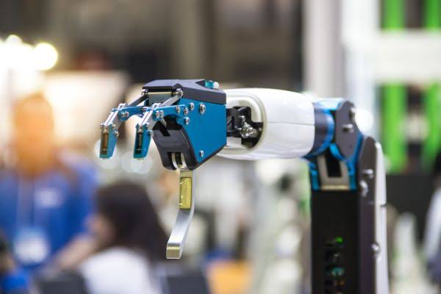

*Fig: 10 Basic robotic arms which is used for working in nuclear power plants.*

**4. Bionics and prosthetics**

Next step bionics and prosthetics is a leader in bionic and prosthetics technology providing only the latest innovations to patients. By working with some of the manufacturers we have direct access to the most progressive advancements on the market. These components are tools for patients to reach their potentials, stay active, confident and achieve their goals.

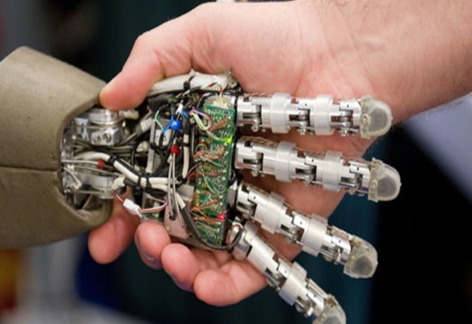 *Fig: 11 Microcontrollers used in a prosthesis.*

Many believe that bionic technology is the wave of future but at the next step we are confident that future innovation is already here. Though other description exists within the prosthetic industry. The next step defines bionics as powered motion with a motor and real time adjustment capability with some electronic devices.

These components astound many with their lifelike functionality and ability to give feedback to the patient. We are proud to offer such a dynamic component to amputees we serve. Additionally, we have access to sophisticated prosthetics devices that manufacturers and other prosthetics providers consider bionic.

While there are many bionic and non-bionic prosthetic components to suit a variety of needs, not everyone is a candidate for most advanced devices and not every insurance plan provides coverage.

Few of the bionic components are Biom Ankle system, Power knee, Proprio foot, Symbiotic leg, Ilimb, Be bionic and Boston Digital arm Non- Bionic components are C- Leg, Genium, Helix 3D Hip, Rheo Knee and Orion Knee.

Bionic Components are the electrical components which are given to the human beings in place of damaged parts of the body. The Non- Biotic components are the components which are given to human beings in addition to other extra parts.

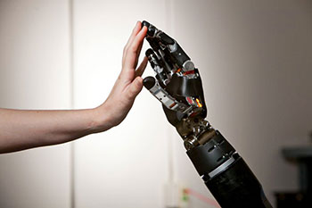

*Fig: 12 Fingers work similar to a human arm.*

The Defense Advanced Research Project Agency funds tend to millions of dollars annually to the advancement of cutting-edge prosthetic limb technology. Their goal is to develop prosthetics limb that approach the function of limbs being replaced. What makes the program unique is its willingness to fund exploratory research in order to make its goal a reality as soon as possible.

This prosthesis is also used for physically challenged persons and also for the person who lost his arm or leg permanently or temporary. These are available at low cost and also at an expensive rate. 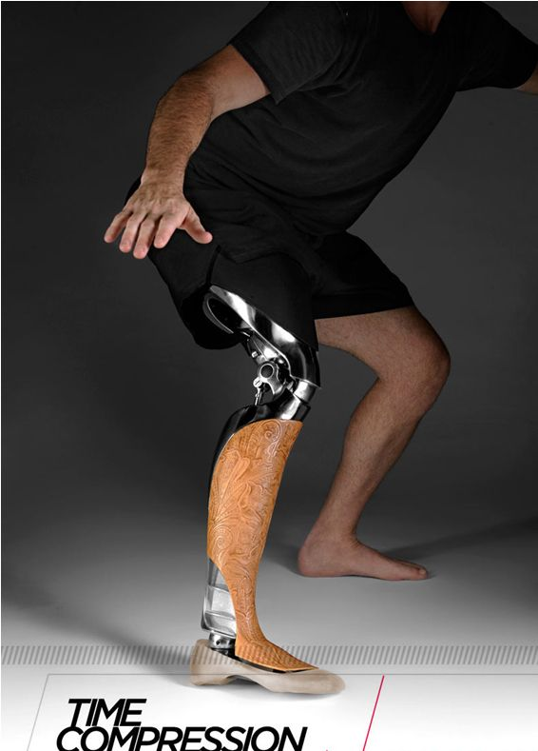 *Fig: 13 Prosthetic leg which can be fixed.*

**5. Bio Mechatronics**

Bio Mechatronics is the merging of man with machine-like cyborg of science fiction. It is an interdisciplinary field encompassing biology, neurosciences, mechanics, electronics and robotics. Bio Mechatronics scientists attempt to make devices that interact with human muscle, skeleton and nervous system with goals of assisting or enhancing human motor control that can be lost or impaired.

This provides the compression effect so that can work effectively. This system has sensors, actuators and a controller. In this presentation, we will find out how Bio Mechatronic devices work using these components, explore the current progress of Bio Mechatronics research and learn about the benefits of such devices. Hence Bio-Mechatronics helps human beings connect the robotic part of the body of human beings.

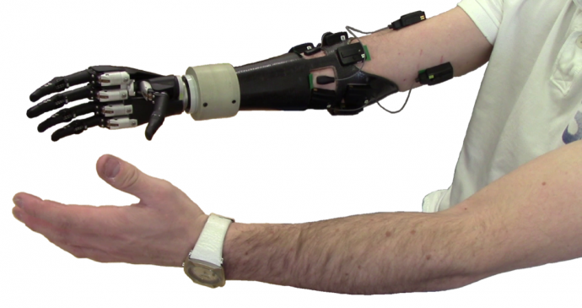

*Fig: 14 Human Impulses which is used for controlling prosthetic arm.*

The use of Bio Mechatronics can provide Mortality to human beings by creating artificial human parts. The scientist has keen on researching for artificial Human Heart, which is extremely advantage for cardiac patients.

When the Prosthetic arm is fixed to the part of Human body, it gets connected to the nervous system also, and hence it is capable of moving according to the brain activity. Therefore, Prosthetics or Robotic-arm works on simple Micro-controller board connections. And hence we can conclude that this Prosthesis can make Human beings Immortal.

**6. CONCLUSION**

Hence this robotic prosthetic proves that there is a connection between humans and machinery. Further can will prove that we can make some other connections between human nervous system and some other machineries. This project will give us the complete details of Prosthetic arm and it’s used. In addition to the bionic arm, it can be used as a third arm for human beings.

**REFERENCE**

[1] Douglas Murphy, *Fundamentals of Amputation Care and Prosthetics (2013).*

[2] Annalisa Milella Donato Di Paola, Graziz Cicirelli, *Mechatronics systems: Simulation Modeling and control (2010).*

[3] Matthias Hackel, *Humanoid Robots: Human- like Machines (2007).*

[4] Peter Mckinnon, *ROBOTICS Everything you need to know about Robotics from Beginners to Expert (2016).*

[5] Cameron Hughes, Tracey, Hughes, *ROBOT PROGRAMMING*: *A Guide to controlling Autonomous Robots (2016).*

[6] Mark W. Spong, Seth Hutchinson, M. Vidyasagar, *Robot Modeling and control (2005).*